**Republic of the Philippines DEPARMENT OF EDUCATION**

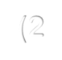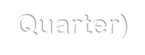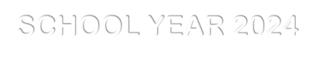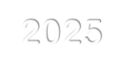

**Region III Division of Nueva Ecija**

**SDO-GENERAL NATIVIDAD**

**GEN. MAMERTO NATIVIDAD NATIONAL HIGH SCHOOL**

***Presents this***

Academic Excellence

*To*

***[name]***

*in recognition of his/her distinguished achievement as a learner*

**[honor]**

(Quarter 1)

SCHOOL YEAR 2024-2025

Given this 16th day of December, 2024 during the 2nd Quarter Recognition at Gen. Mamerto Natividad National High School

Brgy. Poblacion, Gen. M. Natividad, Nueva Ecija.

**ALVIN O. ARENAS SHERYL D. CARIAGA**

**Class Adviser Grade 9 Chairman**